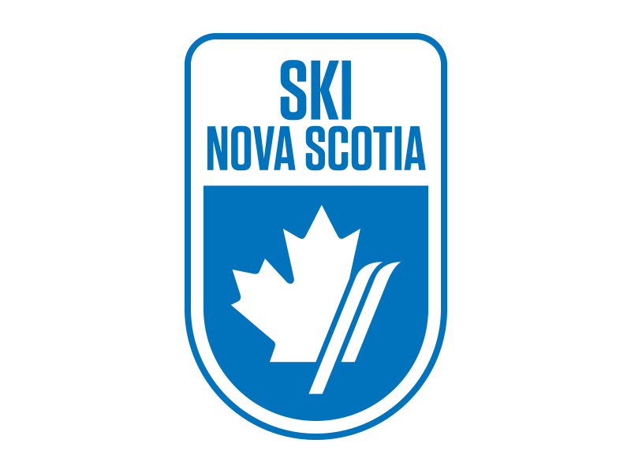
SX CAMP NOTICE
Ben Eoin Ski Team
Thursday and Friday February 6th and 7th, 2020
LOCATION / COURSE – Ski Ben Eoin, SX track
SANCTION – Alpine Ski Nova Scotia / Alpine Canada Alpin
DATES – Thursday, February 6th and Friday, February 7th, 2020
TIMES – Coaches meeting upstairs boardroom, Thursday at 12:30pm. On Snow 1pm-4pm, Thursday. 9:30am-4pm, Friday.
For those coaches doing the SX on snow module, we will meet at 8:30 am in the Chalet on Saturday January 12th. To register for this module go to canskicoach.org Note: In order to register for this module you need to complete the online safety SX module. You will be unable to register if this online module is not completed. For additional information please contact Kevin Elworthy at kevinelworthy@gmail.com or cell 1-902-217-3452.
ELIGIBILITY - Alpine Canada Card holders, Divisions: U8 and up
ENTRY DEADLINE – Saturday February 1st, 2020
ENTRY FEE –
Thursday - $35 only
Friday - $65 only
Total - $100 includes two-day lift passes for each racer and two coach lift tickets per team.
Additional lift tickets are available at a cost of $25 per day.
Cheques are payable to Ben Eoin Ski Team and are to be submitted at the Coach’s meeting or via e-transfer to redrosevp@hotmail.com with BEST2018 as the password. *One cheque per team please.
SX Camp will be under the direction of Kevin Elworthy ACA SX facilitator.
ENTRIES – Send all entries via email to Nancy Nippard, Chief of Administration, at beneoinskiteam@gmail.com. Please list athlete’s full name, National #, gender, DOB, category and Club.
EQUIPMENT – Helmets are mandatory, Back protectors are recommended, GS skis, No Race suits permitted.
ACCOMODATIONS –
The Lakes at Ben Eoin – 902-828-2277
Holiday Inn Express Sydney - 902-562-7500
Travellodge Sydney - 902-539-6750
Cambridge Suites – 902-562-6500

